

ELEVATION SYSTEM MANAGER

PROJECT USER GUIDE

Implementation team:
- Nguyễn Nhật Nam

Instructor: BÙI DUY KHIÊM
Class: ACCP-1809

Date:
This is to certify that
Mr. / Ms.:

Has successfully designed, developed and hosted

ELEVATION SYSTEM MANAGER

Submitted by:
Mr.
(Faculty Guilde’s Name and Signature)

CATEGORY
∞ Ω ∞
- Idea
a. Problem and solution 4
b. The effectiveness of the solution 4
c. Main feature 5
- Identifies entities in the application
- Flowcharts
1. Table flowchart login process, log out of admin,employee 6
2. Table flowchart add, edit, delete of admin (AccountTable) 8
3. Table flowchart add, edit, delete of employee (Product) 9
- Details of entity attributes
Entity Detail 12
Detail of the tables 14
- ERD Model
- Database
1. Table Database 34
2. Diagram 40
- Installation Instructions
- The Main Interface of Project
  - Login Form
  - Account View
  - Client View
  - Product_Elevation View
  - Order View
  - Department View
  - Complain View
  - Status Complain
  - Status Order
  - Role Account

- Assignment table

ELEVATION SYSTEM MANAGER

1. Idea
  - D’Hellas is a france company and was founded on 1987, based on the know-how and license of one of the biggest lift companies. The company concerns manufacturing, trading and maintenance of the complete lift system. It is enlisted among the largest companies in the world. Millions of people in the whole world recognize and rely on D’Hellas.
2. Problem and solution
a. Management Tools:
The company already have website but need an Desktop Application for the internal working of the data within the organization to ensure that the services is provided or not. Apart from manufacturing the lift system and providing the client (“Firm”, “Organization”) and so on it must also take care of maintaining the system. Hence Regularly check up of all the installed system is done by the organization.
b. Difficult to manage:
Usually a salesman must manage: employees, receipts, invoices, coupons ... and must report sales turnover by quarter, year. However, to do this, employees will have to handle a lot of paperwork while not counting the loss of paperwork. This problem requires a software that can store employee data, product, input, output, pay, and parallel data that can be statistically required.

- Benefits of the solution:
  - Easy to add,edit,delete product information.
  - Easy to add client information.
  - Easy to manage.
  - Easily track the growth of your business.
  - Employees work more effectively.

- Some key features of the solution:
- Employees can add,edit, view product information.
- Admin can manage account Employees, manage OrderDetail, Complain of Customer, ...
- Business owners can view sales statistics by month , quarter

- Identifies entities in the application:

- ACCOUNT - Performs for ALL ACCOUNT.
- CLIENT - Performing for entities CLIENT.
- DEPARTMENT - Performing for DEPARTMENT OF EMPLOYEE.
- PRODUCT_ELEVATION - Performing for PRODUCT.
- ORDERS - Performing for ORDER OF CUSTOMER.
- ORDER DETAIL - Performing for ORDER entity.
- COMPLAIN - Performing for COMPLAIN of CUSTOMER.
- ROLE - Performing for PERMISSION of ACCOUNT entity.
- STATUS_COMPLAIN - Performing for STATUS of COMPLAIN.
- STATUS_ORDER – Performing for STATUS of ORDER.

III. Flowcharts
- Table flowchart login process, log out of admin,employee:
The administrator will enter username and password. The system then checks:
- If True will Go To “SystemForm” => Load AccountView
- If False will Request Re-enter uername and password.

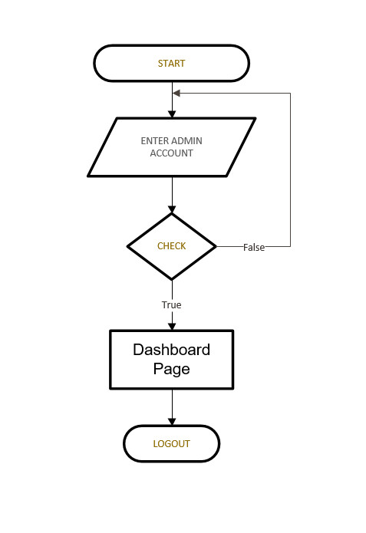

- . Table flowchart add, edit, delete of admin (AccountTable):

- Admin go to the AccountView. Select Action for Account Employee.
- Only Permission for Admin.
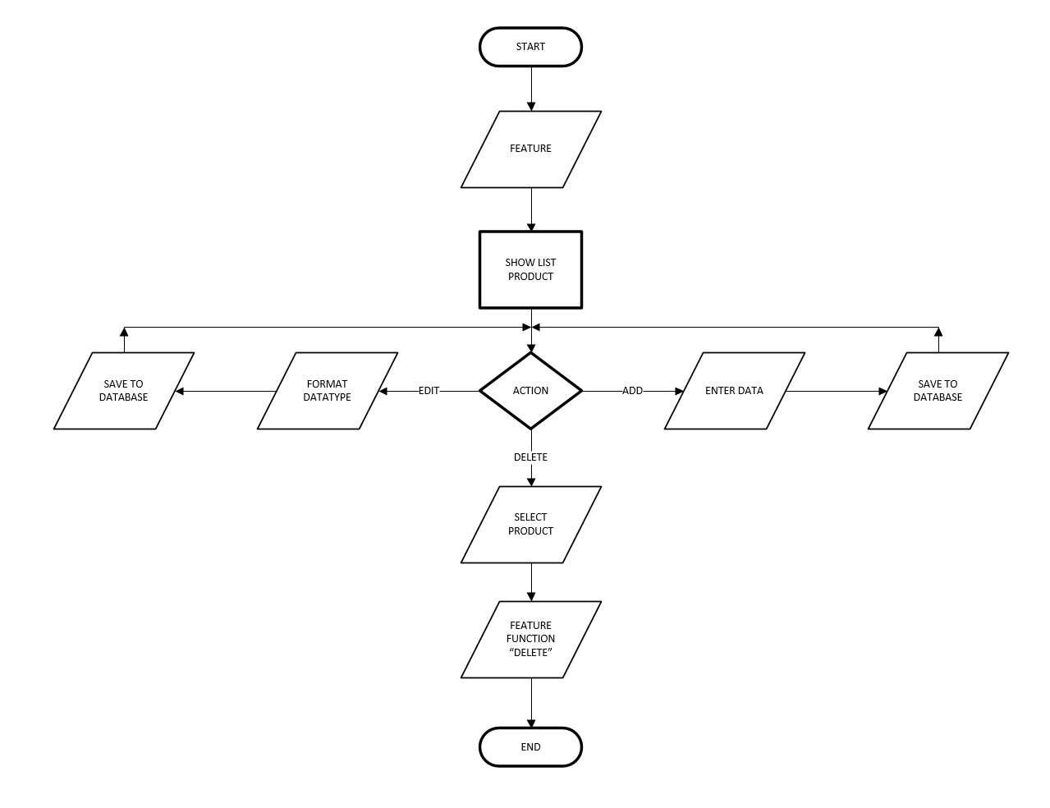

- Table flowchart add, edit, delete of employee (Product):

IV. Details of entity attributes

1. Entity Detail
- ACCOUNT (ID, username, password, name, gender, email, phone, address, role_id, department_id)
- ROLE (ID, name)
- PRODUCT_ ELEVATION (ID, name, type,price, date_of_order, warranty, warranty_expire_date)
- CLIENT (ID, name, phone, address, company_name)
- ORDERS (ID, client_ID,account_ID, total_price, date_of_order, date_of_system_installed, date_of_complete, status_id )
- ORDER_DETAIL (orders_id, product_id , num_of_system_intstalled, price, warranty_period, warranty_expire_date)
- COMPLAIN (ID, order_id, account_id, is_chargeable, problem, date_complain, status_id, technician_person)
- DEPARTMENT (ID, name)
- STATUS_COMPLAIN (ID, name)
- STATUS_Order (ID, name)

3. Detail of the tables.
- ACCOUNT (ID, USERNAME, PASSWORD, NAME, GENDER, EMAIL, PHONE, ADDRESS,ROLE_ID,DEPARTMENT_ID)

Column_name | Type | Allow  Null | Primary  Key | Index | Description
ID | int(11) | No | PK | auto_increment | Primary key
USERNAME | varchar(250) | No
PASSWORD | varchar(250) | No
NAME | varchar(250) | Yes
GENDER | bit | Yes
EMAIL | varchar(250) | Yes
PHONE | varchar(12) | Yes
ADDRESS | varchar(250) | Yes
ROLE_ID | int | Yes | FK
DEPARTMENT_ID | int | Yes | FK

- ROLE (ID, Name)

Column_Name | Type | Allow  Null | Primary  Key | Index | Description
ID | int(11) | No | PK/FK | auto_increment | Primary Key,Foreign Key
Name | varchar(250) | No

- DEPARTMENT (ID, name)

Column_Name | Type | Allow  Null | Primary  Key | Index | Description
ID | int(11) | No | PK | auto_increment | Primary Key
name | varchar(250) | No

- STATUS_COMPLAIN (ID, name)

Column_Name | Type | Allow  Null | Primary  Key | Index | Description
ID | int(11) | No | PK | auto_increment | Primary Key
name | varchar(250) | No

- STATUS_ORDER (ID, name)

Column_Name | Type | Allow  Null | Primary  Key | Index | Description
ID | int(11) | No | PK | auto_increment | Primary Key
name | varchar(250) | No

- CLIENT (ID, name, phone, address, company_name)

Column_Name | Type | Allow  Null | Primary  Key | Index | Description
ID | int(11) | No | PK/FK | auto_increment | Primary Key
name | varchar(250) | No
phone | varchar(250) | Yes
address | varchar(250) | Yes
company_name | varchar(250) | Yes

- PRODUCT (ID, name, type, price, date_of_order, warranty, warranty_expire_date)

Column_Name | Type | Allow  Null | Primary  Key | Index | Description
ID | int(11) | No | PK | auto_increment | Primary Key
name | varchar(250) | No
type | varchar(250) | No
price | int(11) | No
date_of_order | date | Yes
warranty | int(11) | No
warranty_expire_date | date | No

- ORDERS (ID, client_ID,account_ID, total_price, date_of_order, date_of_system_installed, date_of_complete, status_id)

Column_Name | Type | Allow  Null | Primary  Key | Index | Description
ID | int(11) | No | PK/FK | auto_increment | Primary Key, Foreign Key
client_ID | int(11) | No | FK |  | Foreign Key
account_ID | int(11) | No | FK |  | Foreign Key
total_price | int(11) | Yes
date_of_order | date | Yes
date_of_system_ installed | date | Yes
date_of_complete | date | Yes
status_id | int(11) | No

- ORDER_DETAIL (orders_id, product_id , num_of_system_intstalled, price, warranty_period, warranty_expire_date)

Column_Name | Type | Allow  Null | Primary  Key | Index | Description
orders_id | int(11) | No | PK/FK |  | Primary Key,Foreign Key
product_id | int(11) | No | PK/FK |  | Primary Key,Foreign Key
num_of_system_intstalled | int(11) | No
price | int(11) | Yes
warranty_period | int(11) | Yes
warranty_expire_date | date | Yes

- COMPLAIN (ID, order_id, account_id, is_chargeable, problem, date_complain, status_id, technician_person)

Column_Name | Type | Allow  Null | Primary  Key | Index | Description
ID | int(11) | No | PK/FK | auto_increment | Primary Key,Foreign Key
order_id | int(11) | No | PK/FK |  | Primary Key,Foreign Key
account_id | int(11) | No
is_chargeable | int(11) | Yes
problem | int(11) | Yes
date_complain | date | Yes
status_id
technician_person | Varchar(250)

V. Mô hình ERD:

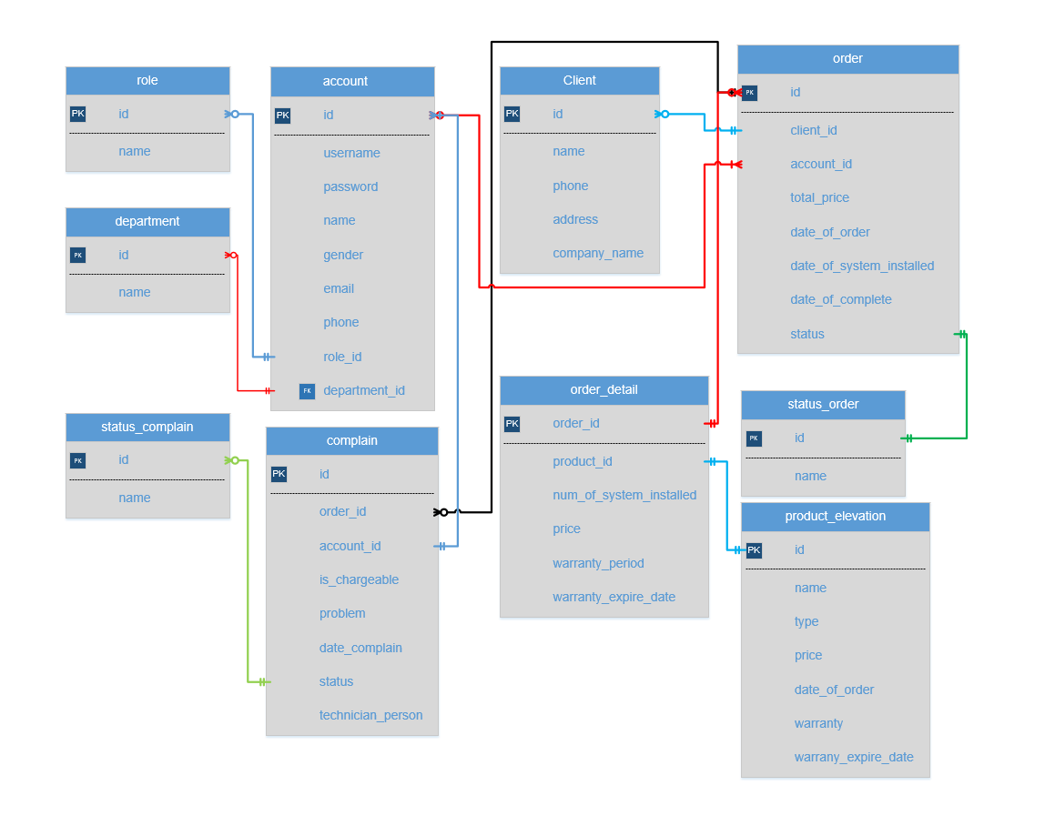

VI. Database
  - Table Database
- Account

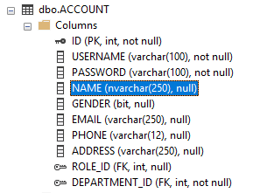
- Client

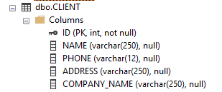
- Complain

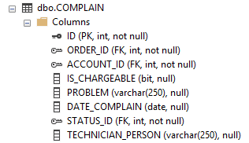

- Department

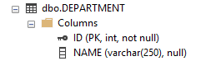
- Orders

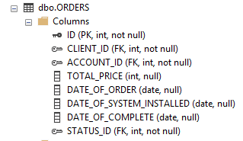
- Order_Detail

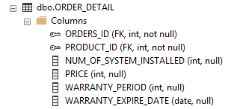
- Product_Elevation

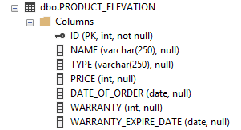
- Role

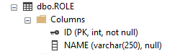
- Status_Complain

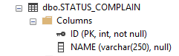
- Status_Order

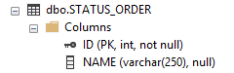

  - Diagram

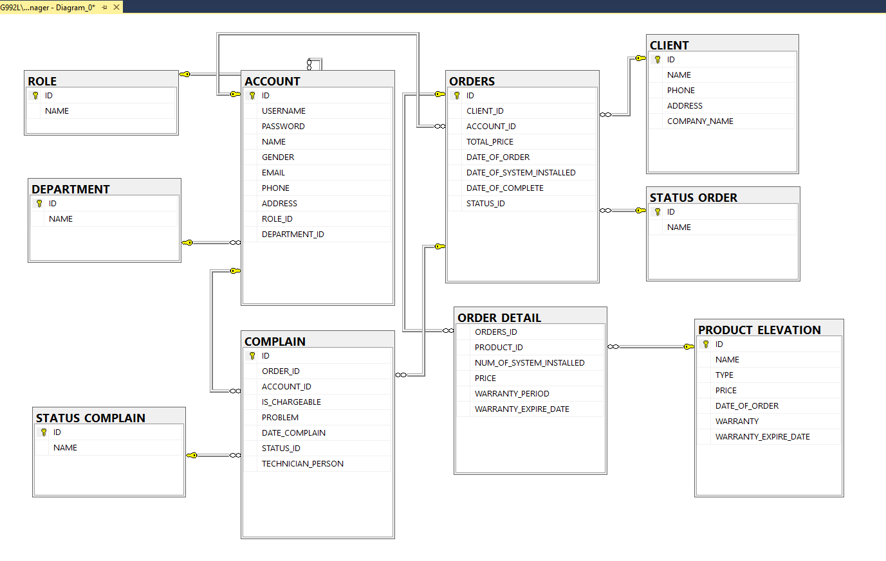
VII. Installation Instructions
- Developer:
  - Hardware Requirements
    - Core i3 or better
    - 8 Gigabyte of RAM or better
  - Software Requirements
    - Windows 10 Pro (or higher if possible)
    - Eclipse IDE for Java EE Developers
    - MS SQL 2012
    - Java SE Development Kit 8u66
- User:
  - Hardware Requirements
    - Core i3 or better
    - 4 Gigabyte of RAM or better
  - Software Requirements
- IE 11 or better
- Chrome 43.0 or better
- Firefox 38 or better

    - The Main Interface of Project
  - Login Form
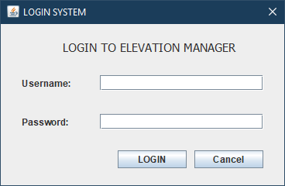

  - Account View
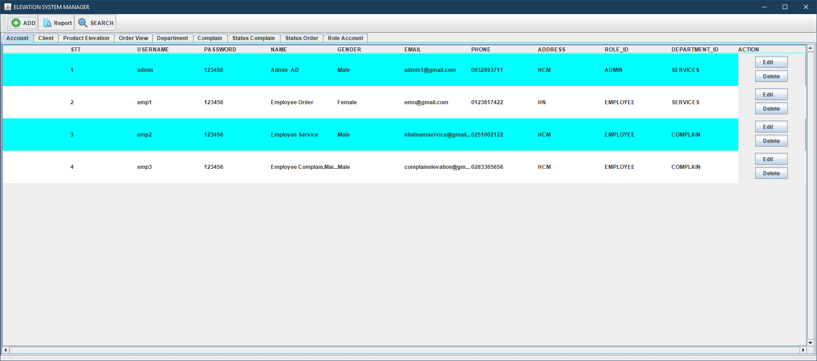

  - Client View
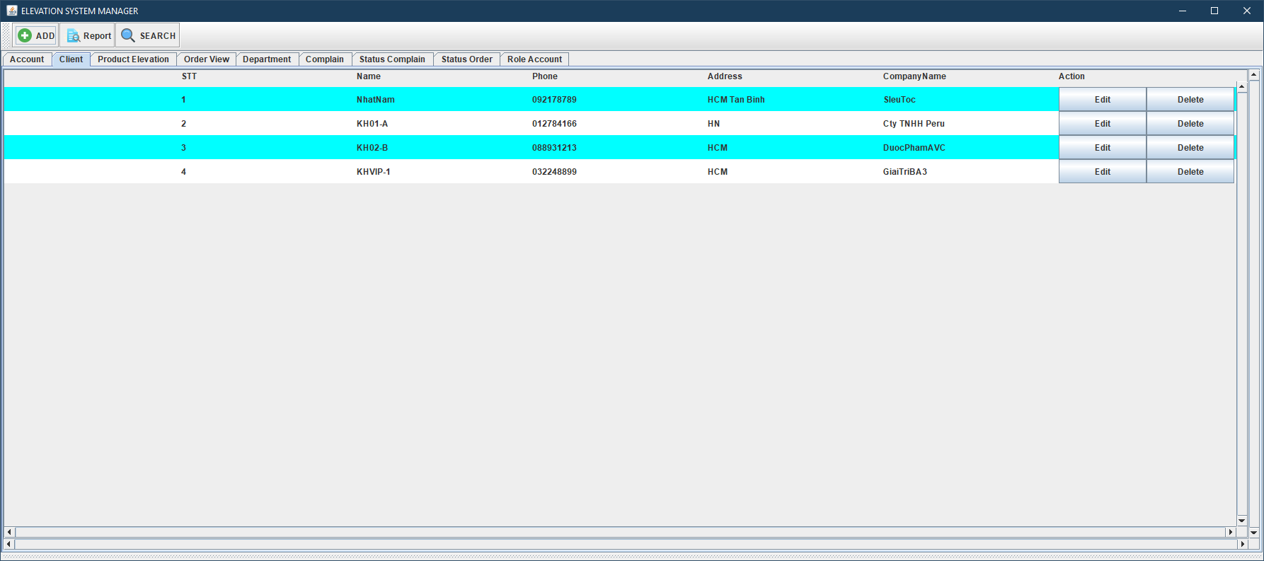
  - Product_Elevation View
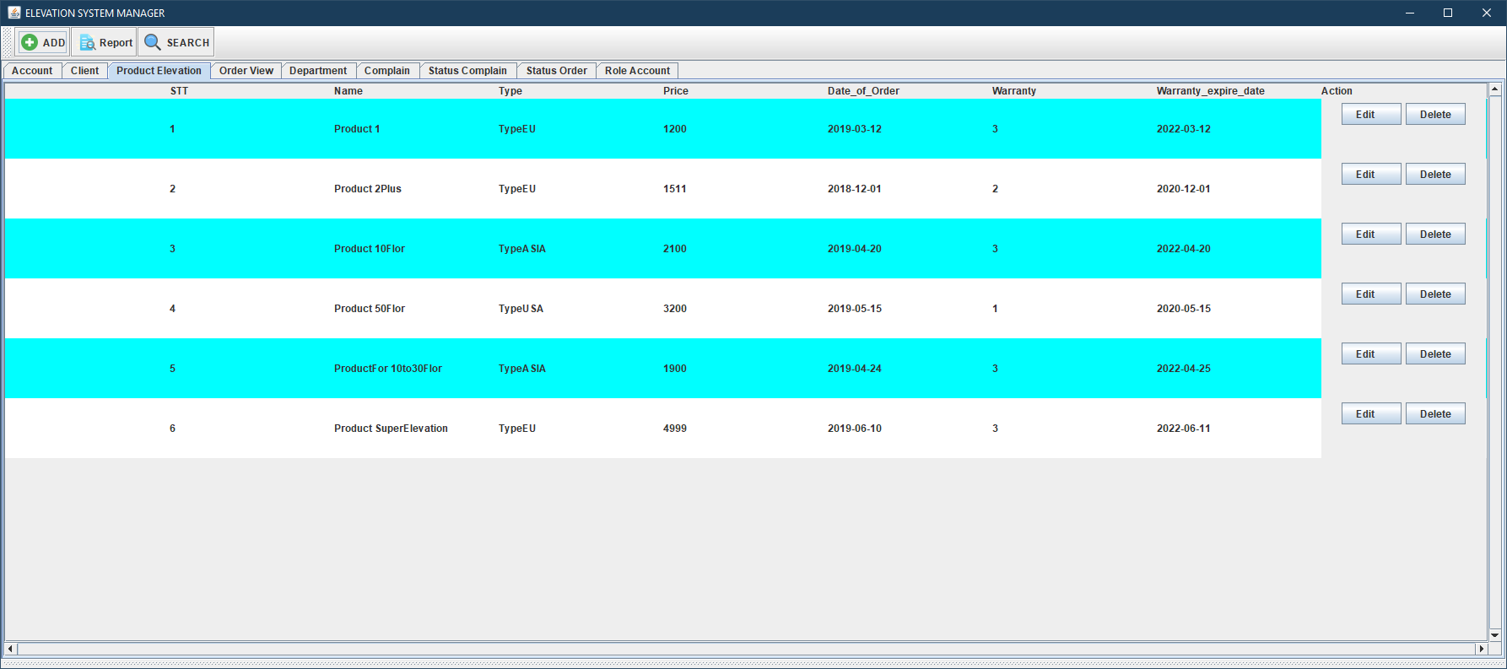

  - Order View
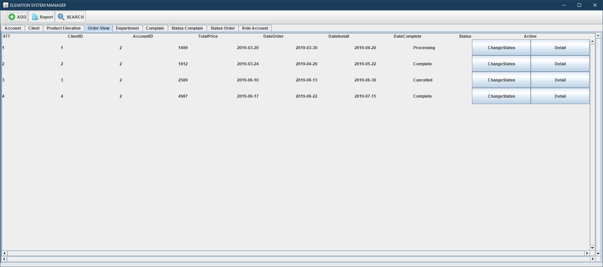

  - Department View
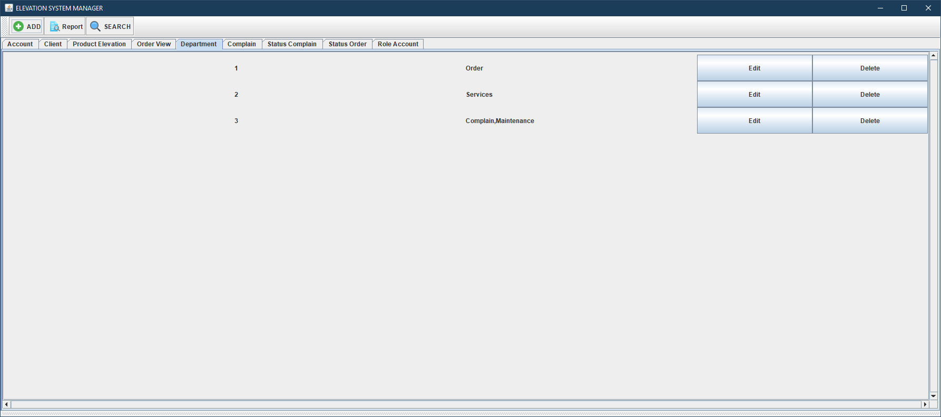

  - Complain View
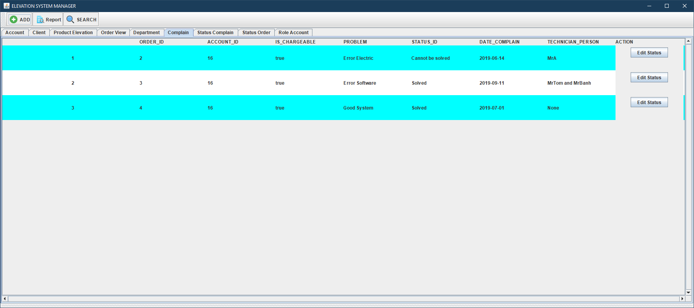

  - Status Complain
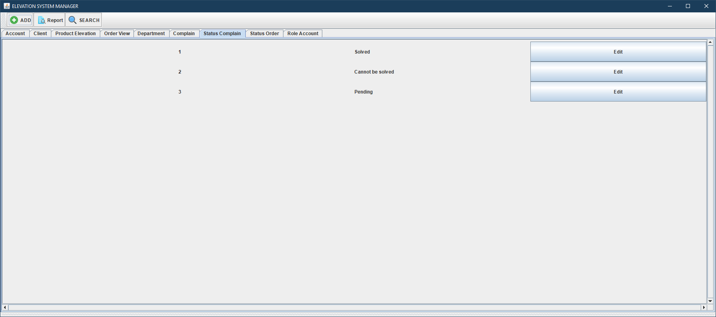

  - Status Order
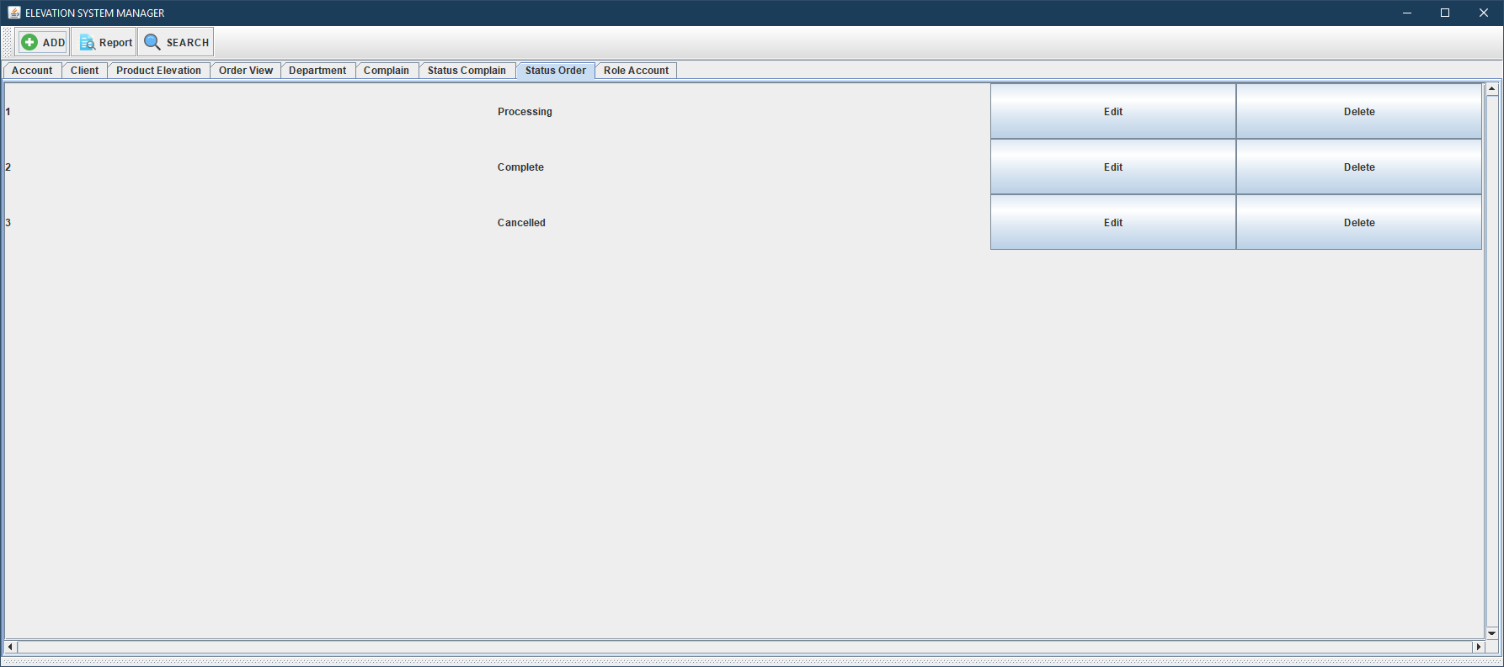
  - Role Account
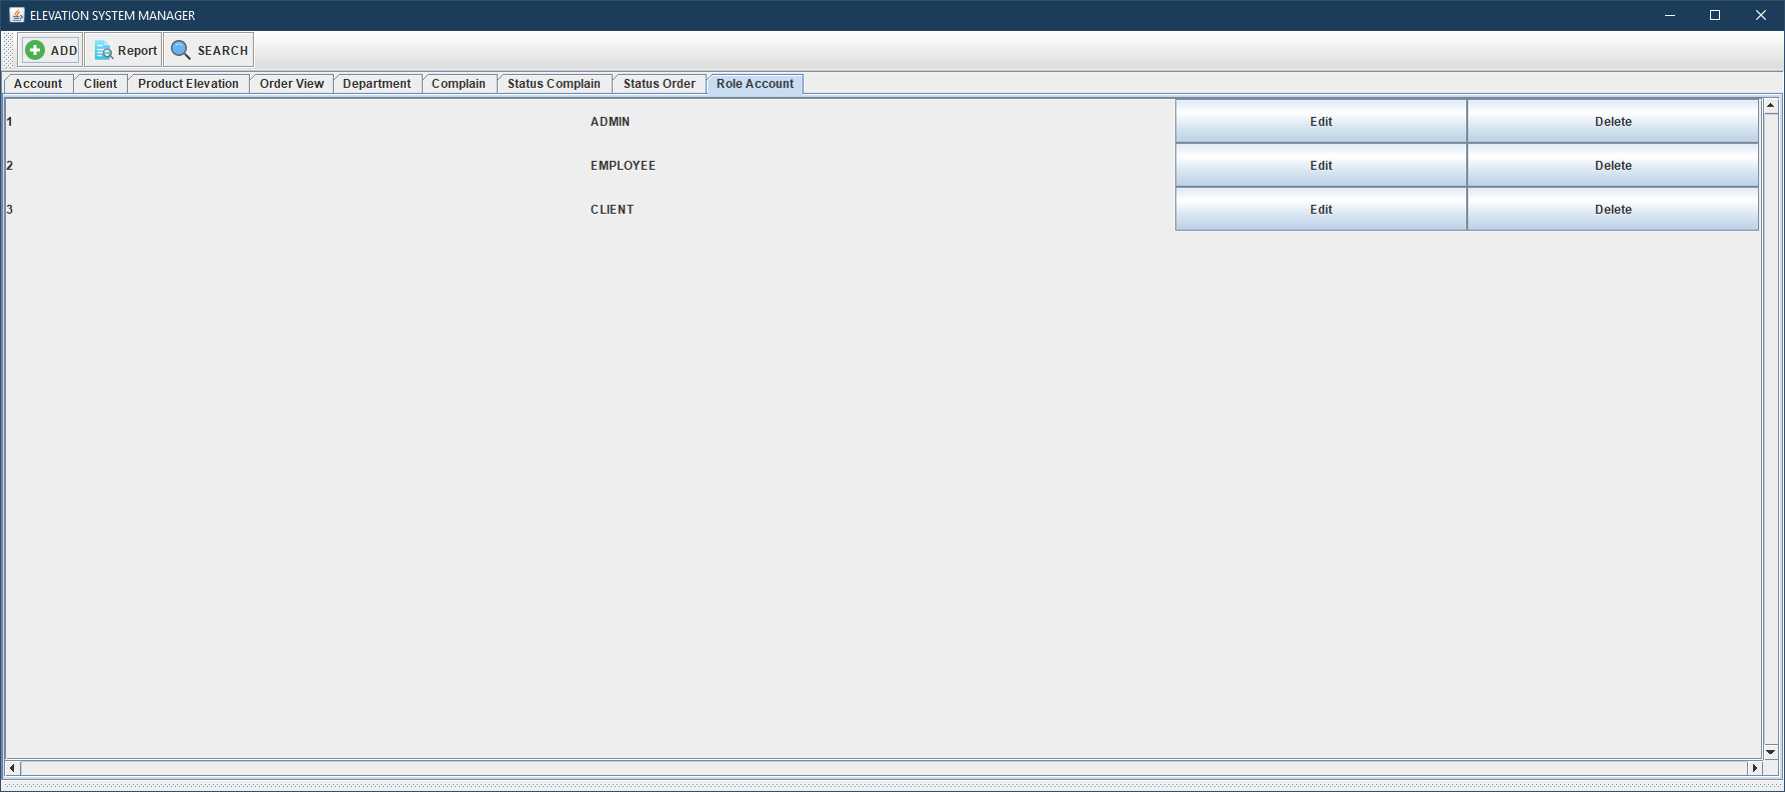
  - Add / Edit Account
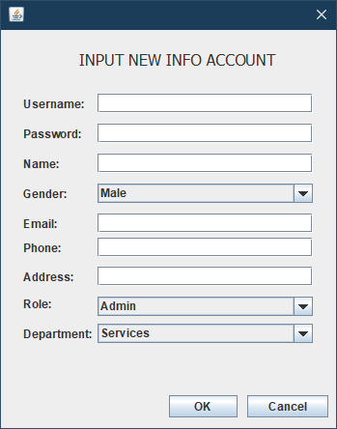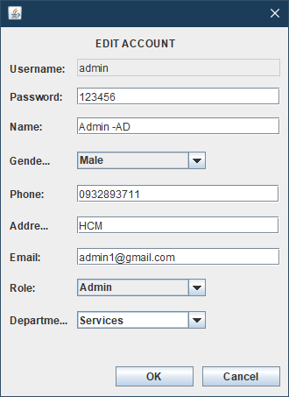
  - Add / Edit Client
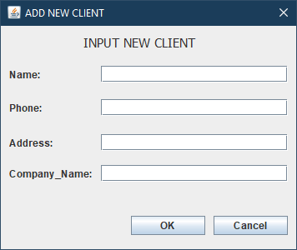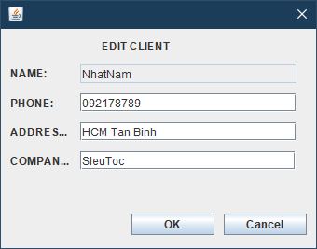
  - Add / Edit Product
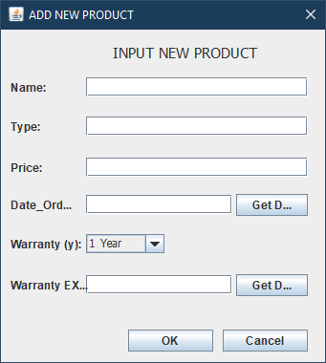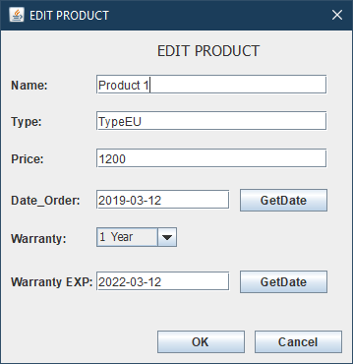

  - Add / Change Status Order
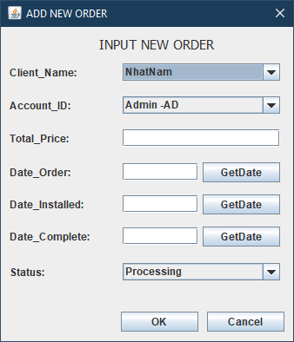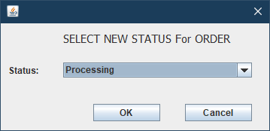
  - Add / Change Status Complain
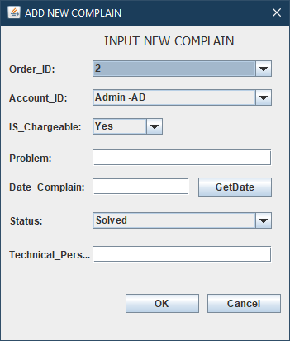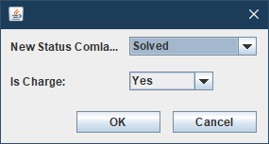

  - Add Orders / Order Detail
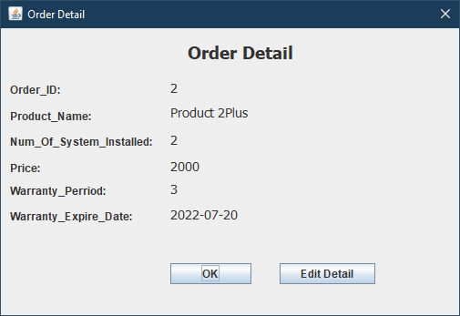

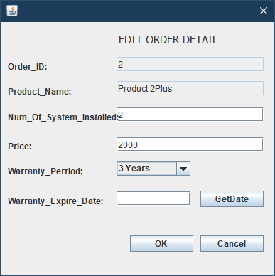

Link Source GitHub Update:
https://github.com/nhatnam0178/ElevationSystemManager

    - Task Sheet
